S_ALR_87013180 -

Functionality
List of Materials by Period Status gives you an overview of the respective period status of the listed materials. You can display the period statuses of the selected materials in each plant for a particular period.

Scenario
Can be used to analyze a status of a material on ad hoc basis

Requirements
Material ledger has been activated.

Menu Path | SAP menu → Accounting → Controlling → Product Cost Controlling → Actual Costing/Material Ledger → Information System → Object List → S_ALR_87013180 - Materials by Period Status
Transaction Code | S_ALR_87013180

STATUS DESCRIPTION
Status | Description
Not defined | Period records do not exist. (technical status)
New objects | Material has been recently created.
Period opened | Period closing program was run.
Price change completed | Price change has taken place for a material.
Quantities and values entered | At least one of the following prerequisites has been met:  - Valuation-relevant goods movements have taken place  - The closing entry has been made for the previous month  In both cases, a price change is no longer allowed.
Values entered | At least one of the following prerequisites has been met:  - Invoices have been received  - An order has been settled  - Materials have been debited/credited.  In all cases, a price change is still allowed.
Price determined, single-level | Single-level material price determination was successful.
Price determined, multilevel | Multilevel material price determination was successful.
Closing entry reversed | The closing entry for a material was reversed.
Closing entry performed | The closing entry for a material has been performed.
1. Double Click on S_ALR_87013180 - Materials by Period Status.

Listing of Materials by Period Status

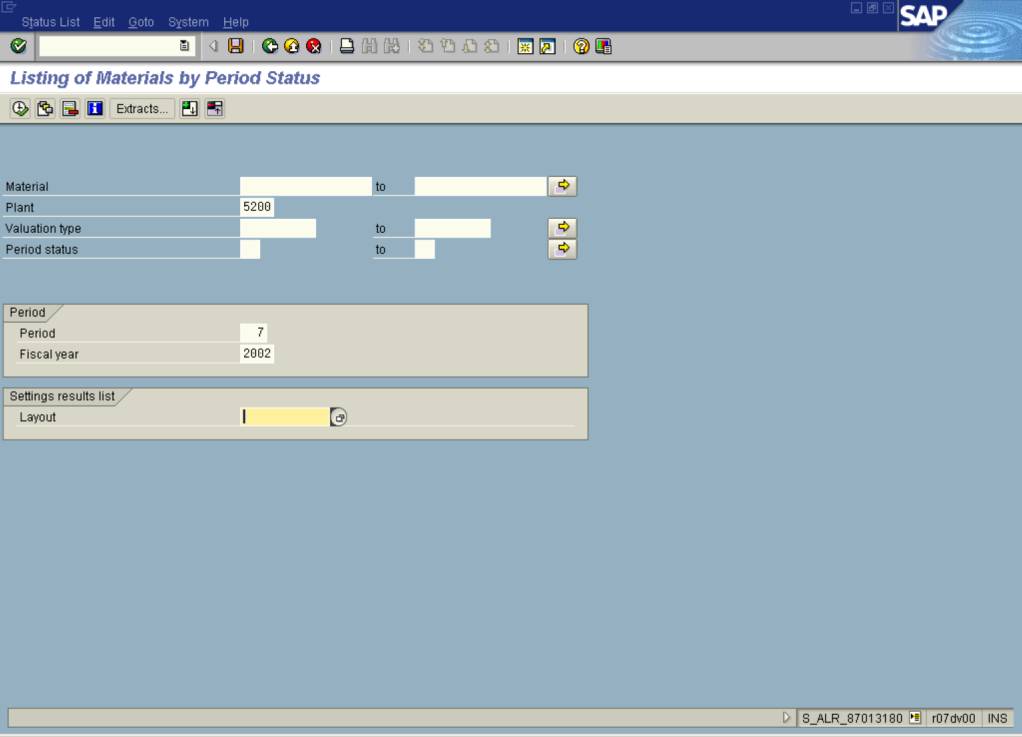

2. Update the following fields:

Field Name | Field Description | Values
Plant | Code identifying the operational unit of the company where the material is manufactured and stored | Example: 5200
Period | Relevant Period | Example: 7
Fiscal year | Relevant Fiscal year. | Example: 2002

3. Click Layout Button .

Layout: Choose

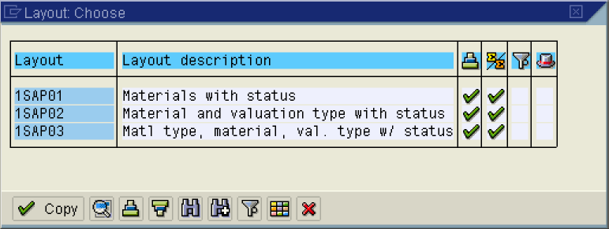

4. Click 1SAP02 Button .

5. Click Button .

Listing of Materials by Period Status
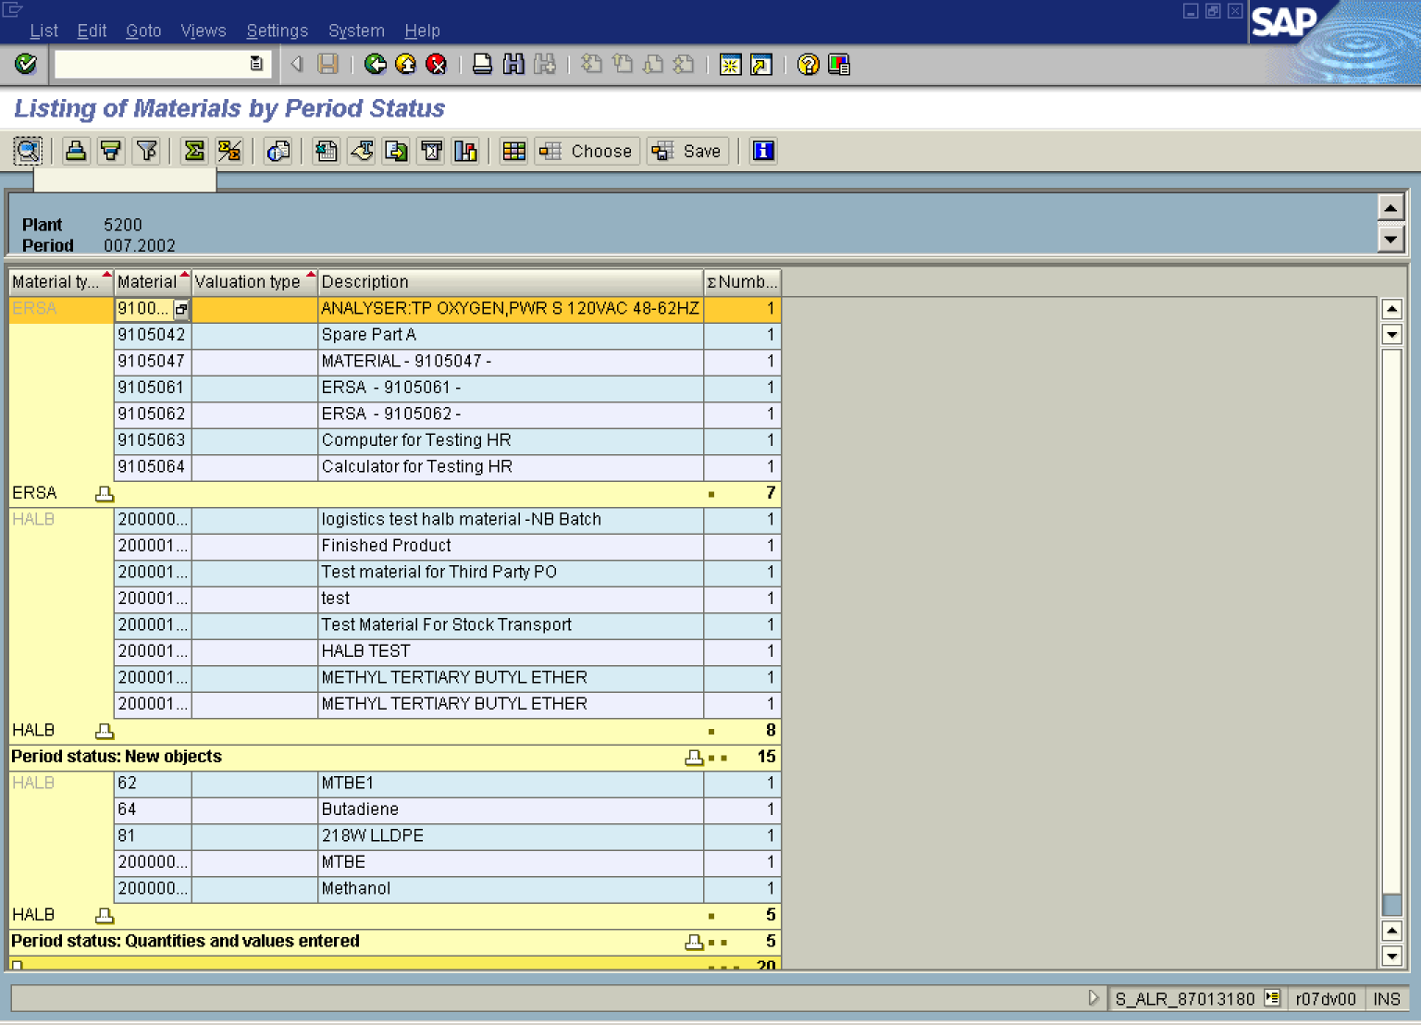
6. Click ERSA Button .

7. Click Period status: New objects Button .

8. Select relevant line.

9. Click Button .

Details

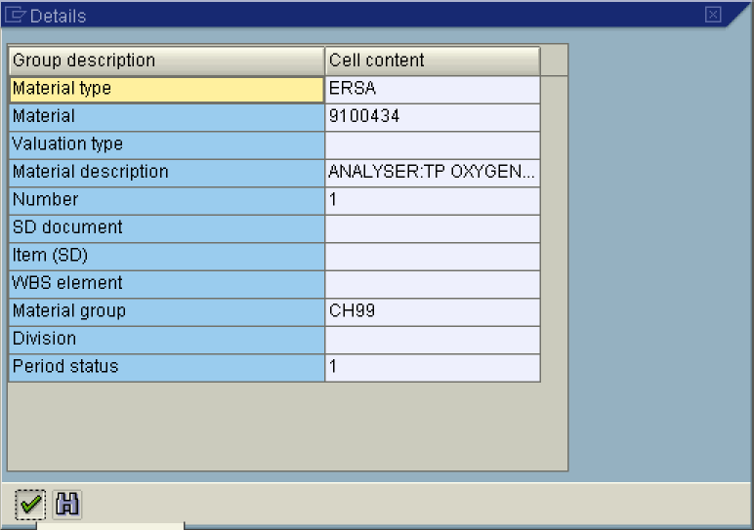

10. Click Button .

11. Click Back .

Listing of Materials by Period Status

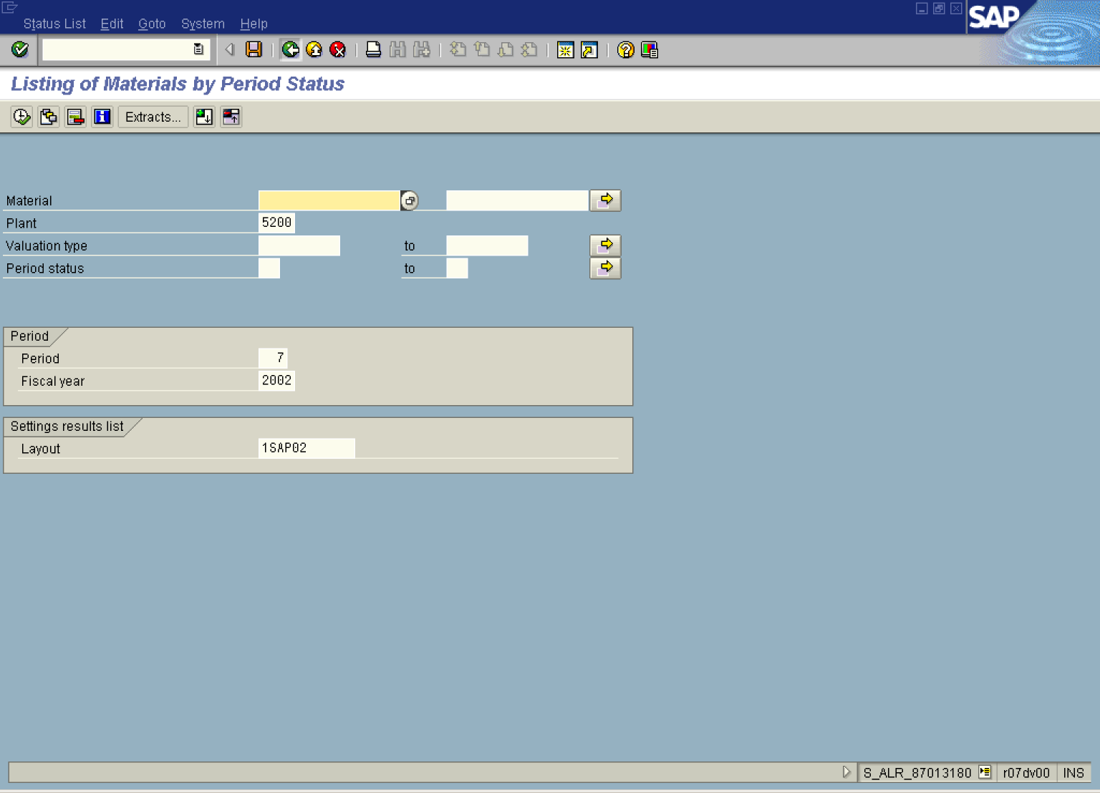

12. Click Back .

